1. Need apis and logic to show groups in signup steps [Prob done already, need to double check again]

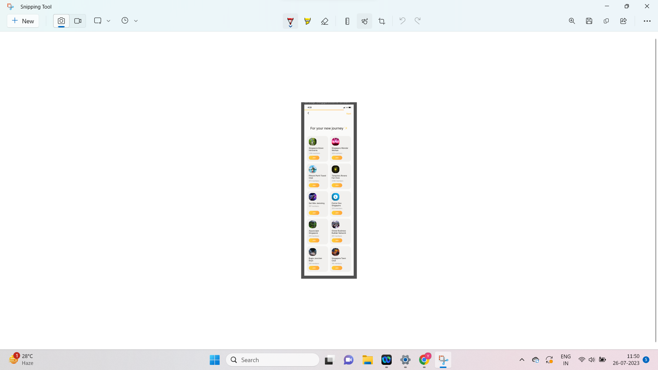

1. Push notification settings

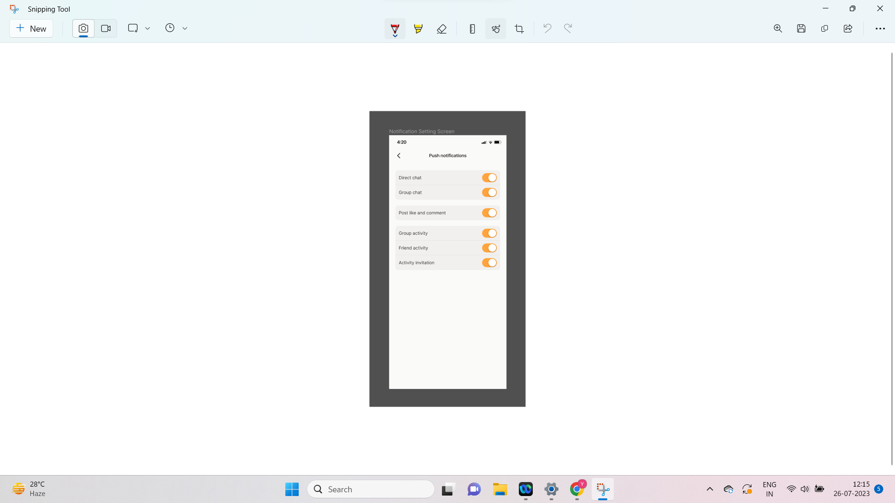

1. Authentication with social logins

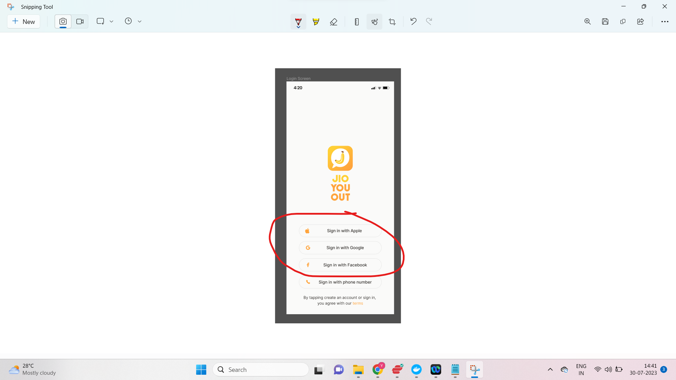

1. Show activity on timeline [Prob done already, need to double check again]

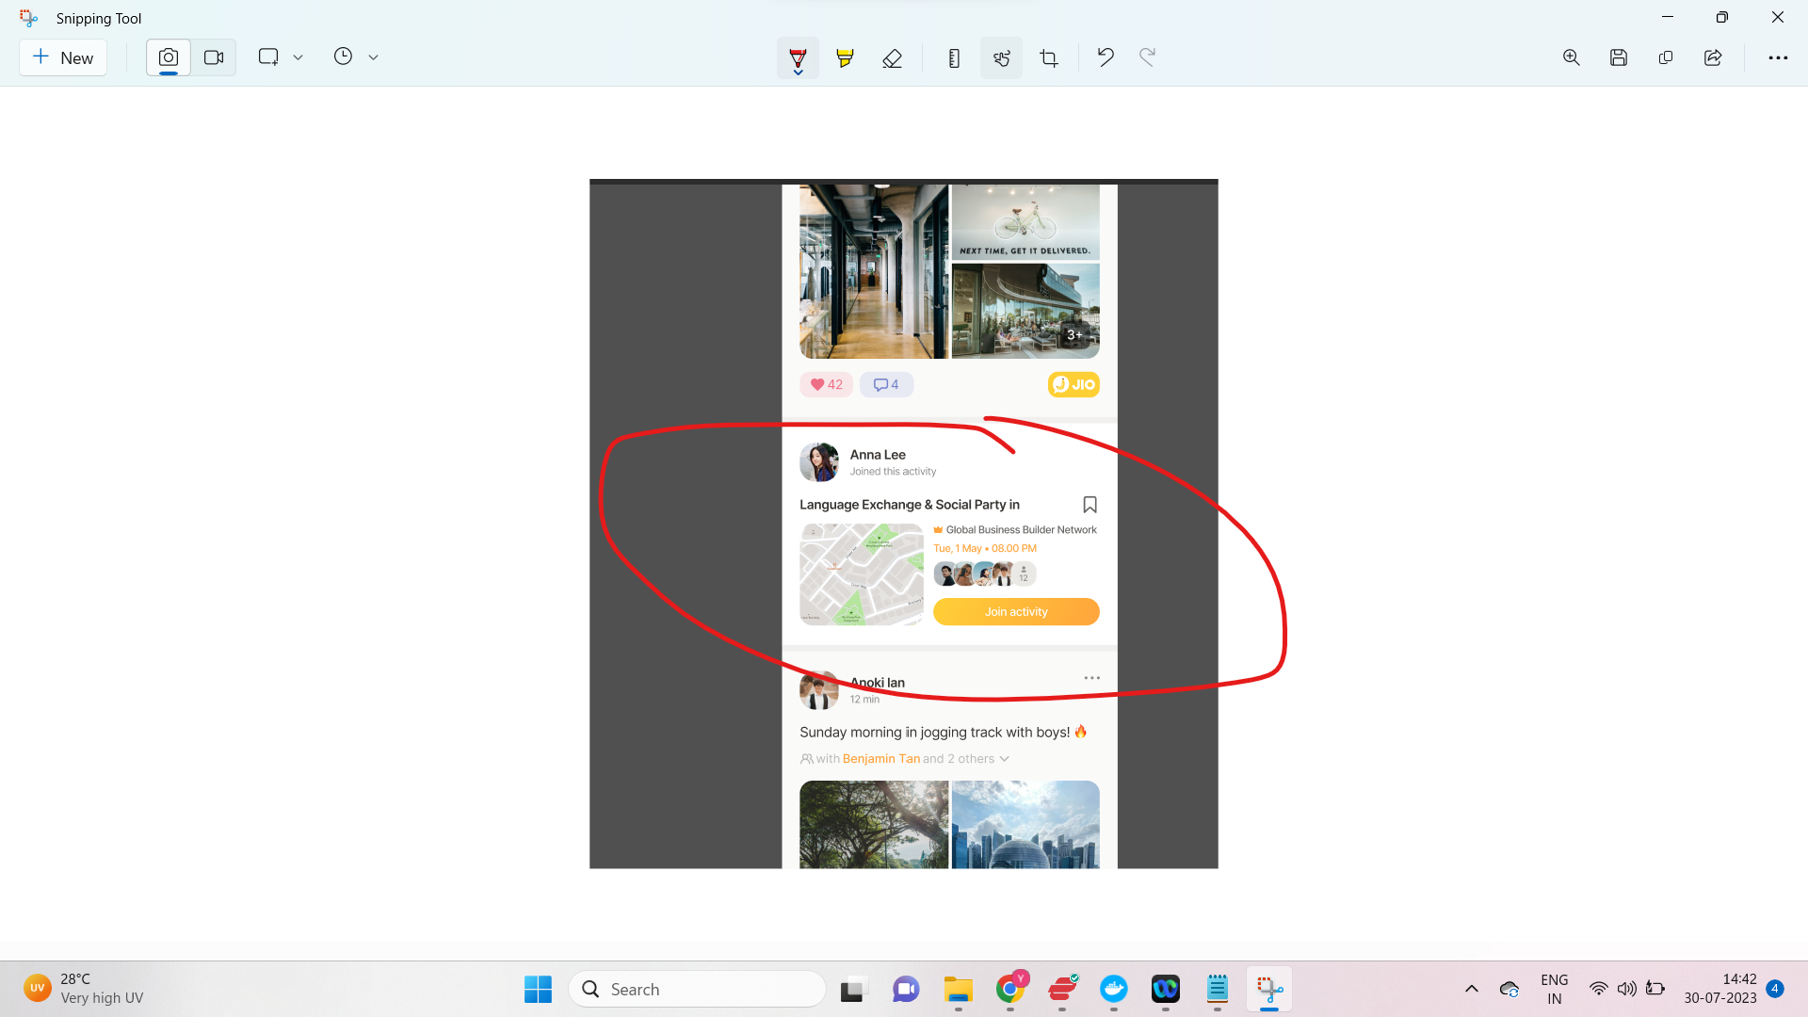

1. Suggest people on timeline [Prob done already, need to double check again]

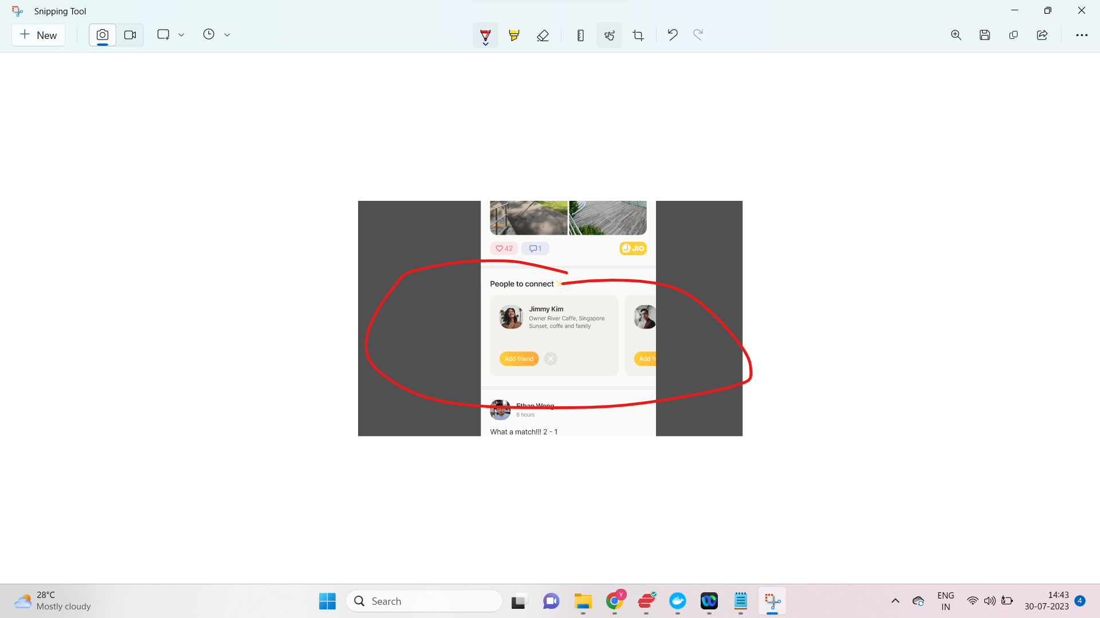

1. Share via, Create a post, Copy Link, Send to Friend for Share Activity, Share Group,

[Need to double check]

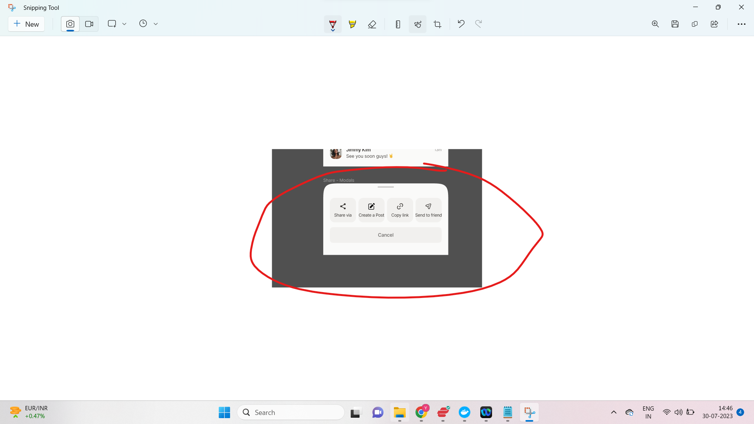

Here copy link concept how does it work its an app and in app there is no link

Create post for activity is done

How does share via work ?

How does send to friend work?

difference between share via and send to friend

share via:

Share by the other social platforms like whatsapp,.

Send to friends :

In the same platform

Once you send this to friend to see the details, the message sent over to them through cometchat

You can send a custom message via Cometchat to that recipient

https://www.cometchat.com/tutorials/build-flutter-chat-app

UI will be smth like this on the message if send activity to friend

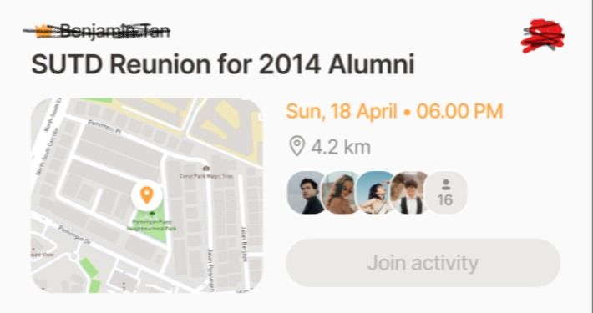

So custom message you can send like an object of CustomMessage, inside object you can add on the location and activity details

From frontend side, will decipher the custom message and display it in this way

1. Delete account [Prob API done already, need Harish to check]
2. Scan QR [Prob done already, need to double check again]
   1. Scan qr will direct to use profile
3. Report activity [Prob API done already, need Harish to check]

10 . Share moments [Prob API done already, need Harish to check]

1. Its basically Sharing Post/Activity to other user outside of the app, once the user has click it, will launch google play or app store if the user does not install the app, else launch the app and direct the user to that specific post/moment